1. Inflow as per system: Inflow Amount from the session as well as Opening Inflow.

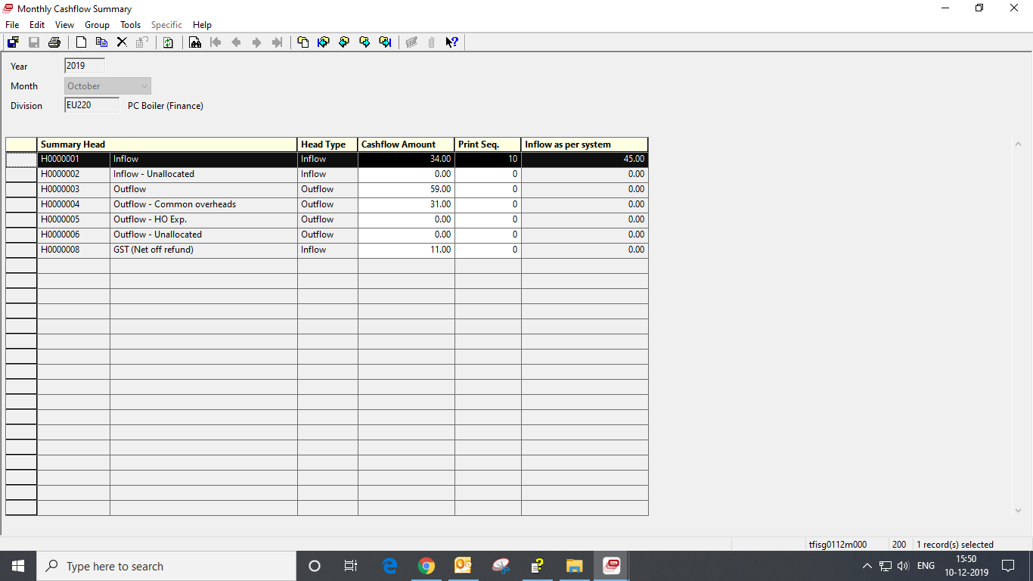

1. Opening Balance:
2. Inflow: Inflow as of 30th Nov
3. Outflow: Outflow as of 30th Nov

